REAL TIME PROGRAMMING LABORATORY

LAB MANUAL
INDEX

S. No | Name of the Content | PAGE NO.
1 | Lab Objective | 3
2 | Introduction About Lab | 4
3 | LAB CODE | 5
4 | List of Lab Exercises | 6
5 | Description about ES Concepts | 7
6 | Programs List | 13
7 | References | 82

2

3

INTRODUCTION ABOUT LAB

There are 30 systems (Dell) installed in this Lab. Their configurations are as follows:

Processor | : | Intel(R) core (TM) - i3 -4150
CPU RAM | : | 4 GB
Hard Disk | : | 500 GB
Mouse | : | Optical Mouse
Network Interface card | : | Present

Software

- All systems are configured in DUAL BOOT mode i.e, Students can boot from Windows 07.This is very useful for students because they are familiar with different Operating Systems so that they can execute their programs in different programming environments.

- Each student has a separate login for database access

- Software installed: Keil Micro vision, OFFICE-07, Systems are provided for students in the1:1 ratio.

- Systems are assigned numbers and same system is allotted for students when they do the lab.

5

List of Lab Excercises

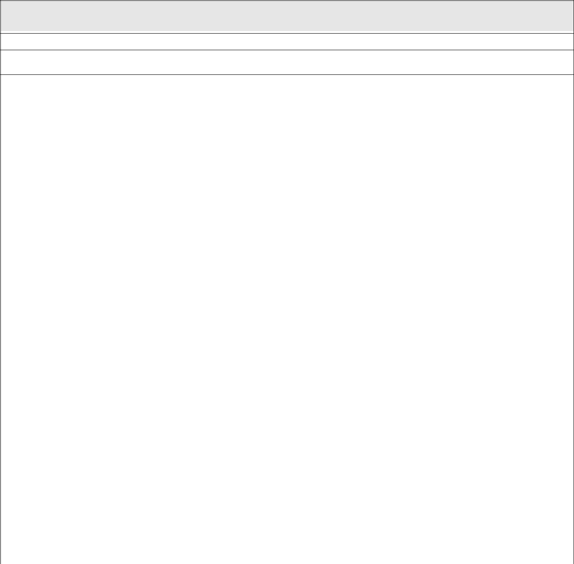

REAL TIME PROGRAMMING LABORATORY – Lab Programs List

Submission – 1

Week – 1 | Program to toggle all the bits of port P1 continuously with 250 ms delay.
Week – 2 | Program to interface a switch and a buzzer to two different pins of a port such that the buzzer
Week – 2 | should sound as long as the switch is pressed.
Week – 3 | Program to interface LCD data pins to port P1 and display a message on it
Week – 4 | Program to interface seven segment display using 89V51RD2
Week – 5 | Program to interface keypad. Whenever a key is pressed, it should be displayed on LCD
Week – 6 | Program to transmit message from microcontroller to PC serially using RS232
 | Program to receive a message from PC to microcontroller serially using RS232
Week – 7 | Program to interface Stepper Motor to rotate the motor in clockwise and anticlockwise
 | Directions
Week – 8 | Program to read data from temperature sensor and display the temperature value
Week – 9 | Port RTOS on to 89V51 Microcontroller and verify. Run 2 to 3 tasks
Week – 9 | simultaneously on 89V51 SDK. Use LCD interface, LED interface,
 | Serial communication.
Week – 10 | Program to convert analog signal into digital (ADC).
Week – 11 | Program to convert Digital into Analog (DAC).
Week – 12 | Program to interface Elevator.

6

Description about ES Concepts:

Real time programming systems are designed to do some specific task, rather than be a general-purpose computer for multiple tasks. Some also have real-time performance constraints that must be met, for reason such as safety and usability; others may have low or no performance requirements, allowing the system hardware to be simplified to reduce costs. Real time programmings are not always separate devices. Most often they are physically built-in to the devices they control.

The software written for Real time programmings is often called firmware, and is stored in read-only memory or Flash memory chips rather than a disk drive. It often runs with limited computer hardware resources: small or no keyboard, screen, and little memory. Real time programmings range from no user interface at all

— dedicated only to one task — to full user interfaces similar to desktop operating systems in devices such as PDAs. Simple embedded devices use buttons, LEDs, and small character- or digit-only displays, often with a simple menu system.

Real time programming’s components:
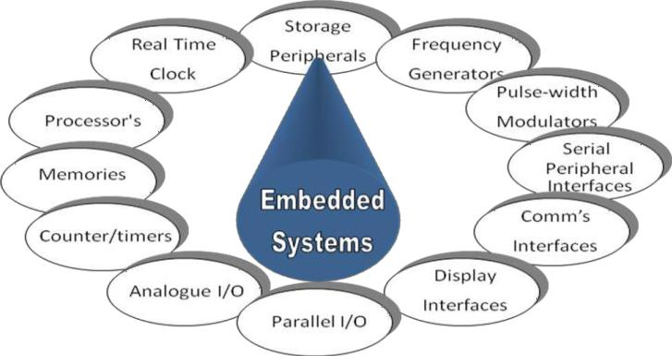

7

Introduction to 8051 Microcontroller:

- Microcontroller is a device which integrates number of components of a microprocessor system onto a single chip. It typically includes:-

  - CPU (Central Processing unit)

  - RAM & ROM

  - I/O inputs & outputs – Serial & Parallel

  - Timers

  - Interrupt Controller

By including the features that are specific to the task (Control), Cost is relatively low.

Microcontroller are a ―one chip solutions‖ which drastically reduces parts count and design costs.

Block Diagram:
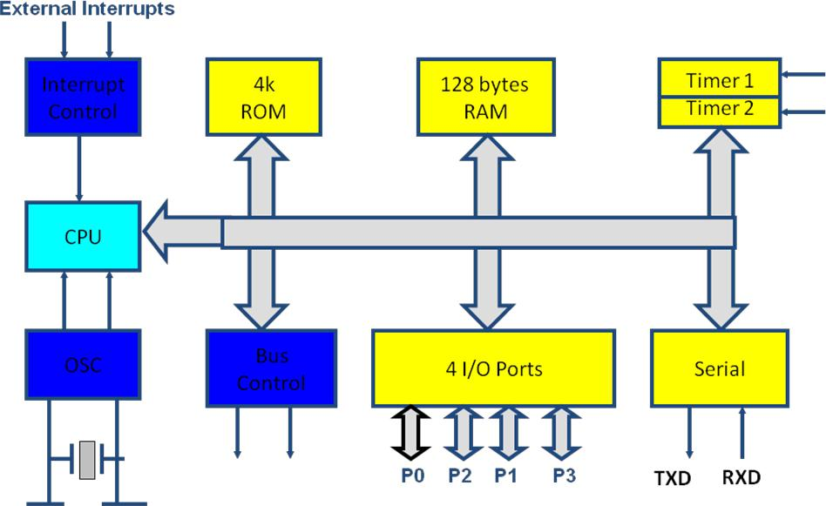

8051 Basic Components:

- 4K bytes internal ROM

- 128 bytes internal RAM

- Four 8-bit I/O ports (P0 - P3).

- Two 16-bit timers/counters

- One serial interface

8

8051 features:

- 4K bytes ROM

- 128 bytes RAM

- Four 8-bit I/O ports

- Two 16-bit timers

- Serial interface

- 64K external code memory space

- ALU

- Working Registers

- Clock Circuits

- Timers and Counters

- Serial Data Communication.

8051 CPU Registers:
- A (8-bit Accumulator)

- B (8-bit register for Mul &Div)

- PSW (8-bit Program Status Word)

- SP (8-bit Stack Pointer)

- PC (16-bit Program Counter)

- DPTR (16-bit Data Pointer)

Pin Description of the 8051:
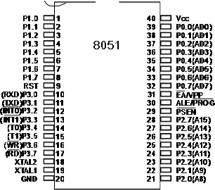

- The 8051 is a 40 pin device, but out of these 40 pins, 32 are used for I/O

- 24 of these are dual purpose, i.e. they can operate as I/O or a control line or as part of address or date bus.

9

8051 Development Board

(P89V51RD2)

On board Peripherals:

1) hex-key pad

3) serial peripheral interface (spi)
5) analog to digital converter
7) digital to analog converter
9) eeprom (i2c)
11) lcd display

13) lcd contrast (potentiometer)
15) crystal oscillator

17) serial port connector
19) buzzer
21) push button switches

23) ps/2 connector
25) power supply slide switch

27) 7805 voltage regulator
29) relay

2) seven segment display
4) led‘ display

6) lm35 temperature sensor
8) rtc battery
10) rtc
12) gnd and vcc

14) p89v51rd2
16) max232

18) stepper motor driver
20) reset button
22) slide switches

24) relay output connector
26) power jack

28) bridge rectifier

Overview:

The UTS-MC-KIT-M7.3 has got P89V51RD2 microcontroller which has got 64KiloBytes of on chip Flash memory and 1 KiloBytes of RAM. The kit is has got on board 11.0592MHz crystal for generating the on chip clock of 11.0592MHz.

A Key feature of the board is it has got so many interfaces, with different on board peripherals and has got expansion capability to add any further sensor and peripherals in future. This prototype board is very easy to use for 8051 architecture. This board is interfaced with LED‘s, 7 SEG display, LCD display, Pushbutton. This Board can also be interfaced with PC via serial communication and can be viewed through hyper terminal. The LCD display can be connected easily through connectors. No soldering work /No lose contact/ just plug in the berg connectors.

The board has got on chip peripherals like on board 32 KB bytes of RAM, Eight Light Emitting Diodes, four Push Buttons, Four Seven Segment Displays, 16X2 Liquid Crystal Character Display(LCD), Analog to Digital Converter, LM35 Temperature sensor, SPI based ADC, Hex Keypad, Buzzer relay, steeper motor driver interface, Real time clock, RS-232 serial interface.

10

Component Description:
Microcontroller
The P89V51RD2 device contains a non-volatile 64KB Flash program memory.

In-System Programming (ISP) allows the user to download new code while the microcontroller sits in the application. A default serial loader (boot loader) program in ROM allows serial In-System programming of the Flash memory via the UART without

the need for a loader in the Flash code.

This device executes one machine cycle in 6 clock cycles, hence providing twice the speed of a conventional 80C51. An OTP configuration bit lets the user select conventional 12 clock timing if desired.

This device is a Single-Chip 8-Bit Micro controller manufactured in advanced CMOS process and is a derivative of the 80C51 micro controller family. The instruction set is 100% compatible with the 80C51 instruction set.

The device also has four 8-bit I/O ports, three 16-bit timer/event counters, a multisource, and four-priority-level, nested interrupt structure, an enhanced UART and on-chip oscillator and timing circuits.

The added features of the P89V51RD2 makes it a powerful micro controller for applications that require pulse width modulation, high-speed I/O and up/down counting capabilities such as motor control.

Experimental Procedure for Keil4 IDE

(For all the experiments this procedure is same)

The RVision IDE is, for most developers, the easiest way to create Real time programming programs.

This chapter describes commonly used RVision features and explains how to use them.

RVision is a Windows application that encapsulates the Keil microcontroller development tools as well as several third-party utilities. RVision provides everything you need to start creating embedded programs quickly. RVision includes an advanced editor, project manager, and make utility, which work together to ease your development efforts, decreases the learning curve, and helps you to get started with creating embedded applications quickly.

There are several tasks involved in creating a new embedded project:

- Creating a Project File

- Using the Project Windows

- Creating Source Files

- Adding Source Files to the Project

- Using Targets, Groups, and Files

- Setting Target Options, Groups Options, and File Options

- Configuring the Startup Code

- Building the Project

- Creating a HEX File

The below section provides a step-by-step tutorial that shows you how to create an embedded project using the RVision IDE.

11

Downloading the hex file to the target using Flash magic Software:

Open the Flash Magic tool for downloading into the Microcontroller Board. Click on Device menu select option you will be popped up with a window named choose device. Under choose device options select 8051 and click on Ok button to open flash magic tool to download the hex file in to the MC

Terminal Software for Check the Serial port Data receiving from Microcontroller to PC:

Terminal is a simple serial port (COM) terminal emulation program. It can be used for communication with different devices such as modems, routers, embedded microcontroller systems, GSM phones, GPS modules... It is very useful debugging tool for serial communication applications.

12

13

14

EXPERIMENT – 1

Aim:

Write a Embedded C Program to toggle all the bits of Port P1 continuously with 250 mS delay led blink with 89V51RD2 microcontroller board

Equipment Requirements:

- Hardware Requirements :

  - 89V51RD2 Development board

  - A serial 9 pin cable wired one to one from female connector to male connector

  - PC with serial port

  - 9V adaptor

  - Connecting jumper and Connecting Wires.

- Software Requirements:

    - Flash Magic tool.

    - Keil evaluation software

LEDs Interfacing with 8051:
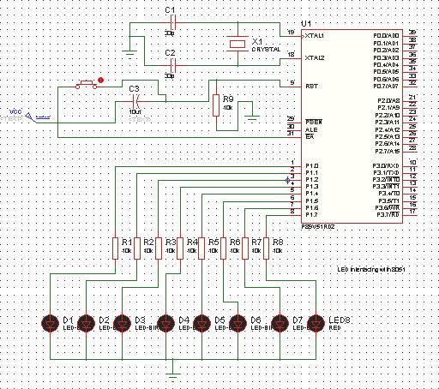

-22-

Source code:

/* Program to toggle all the bits of Port P1 continuously with 250 mS delay. */

#include<REG51.H>

#define LEDPORT P1

void delay(unsigned int); void
main(void)

{
LEDPORT =0x00;
while(1)

{
LEDPORT = 0X00;
delay(250); LEDPORT = 0x11;

delay(250);
}
}
void delay(unsigned int itime)
{
unsigned int i,j;

for(i=0;i<itime;i++)

{
for(j=0;j<250;j++);

}
}

Flow Chart:
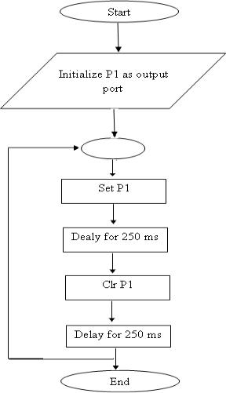

-23-

Hardware configuration:

- Connect an 8 pin bus from Port 1 (P1) to the LED pins (No 3 pin strip) or place an 8 pin Jumper connecting No2 and No3 pin strips.
- Turn Off and On the Board or just reset it to view the output.

Results/Output verification:

Now the led program is running on Microcontroller. And the output can be seen in the board. You can see led toggling
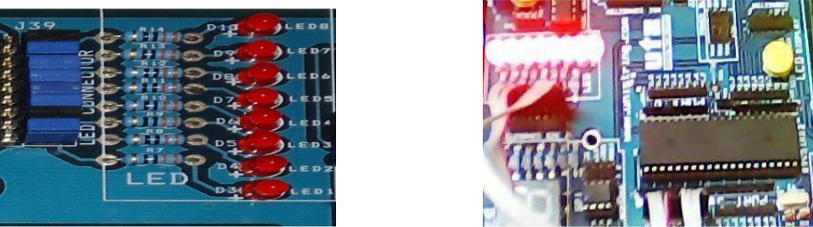

-24-

-25-

EXPERIMENT – 2

Aim:

Write a Embedded C Program to interface a switch and a buzzer to two different pins of a port such that the buzzer should sound as long as the switch is pressed.

Equipment Requirements:

Hardware Requirements:

- 89V51RD2 Development board

- A serial 9 pin cable wired one to one from female connector to male connector

- PC with serial port

- 9V adaptor

- Connecting jumper and Connecting Wires.

Software Rquirements :

- Keil evaluation software

- Flash Magic tool.

Interfacing Switch & Buzzer with 8051:
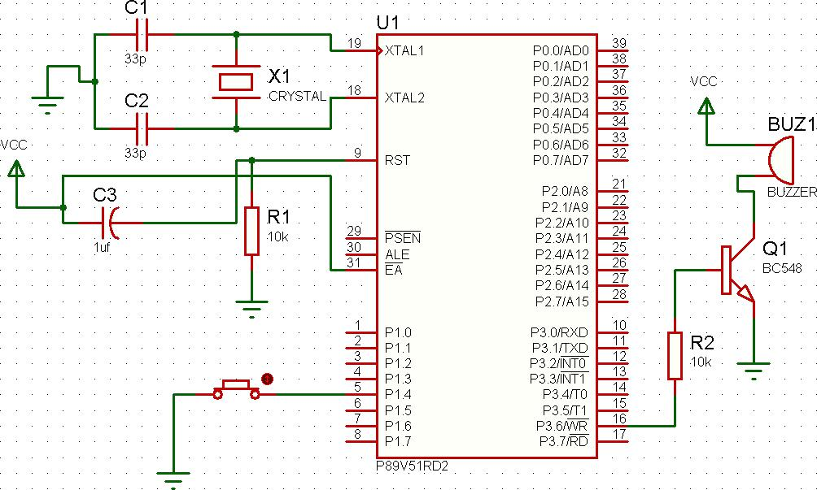

-26-

Source code:

/*Program to interface a switch and a buzzer to two different pins of a Port such that the buzzer

should sound as long as the switch is pressed.*/

#include <REG51.H> // special function register declarations for the intended 8051 derivative

sbit SW1 = P1^4;

sbit BUZZER = P3^6;

void main (void)

{

BUZZER = 0;
while(1)

{

if(SW1 == 0)
{

BUZZER = 1;
}

else
BUZZER = 0;
}

}

Flow Chart:
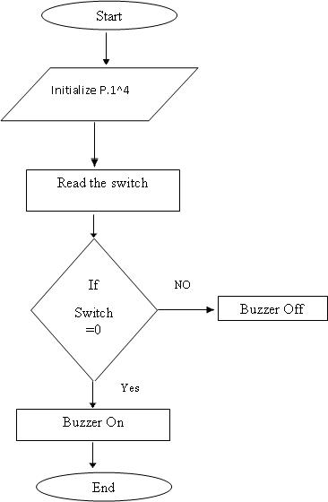

-27-

Hardware configuration:

- Connect a single pin wire from PORT 1.4 to any switch available on board.

- Place the jumper at jp6 jumper position to connect the buzzer onboard to the controller.

- Turn ON and OFF or reset the board, to view the output.

Results/Output verification:

After programming the code into the microcontroller just reset the microcontroller. You can listen to the buzzer buzzing.
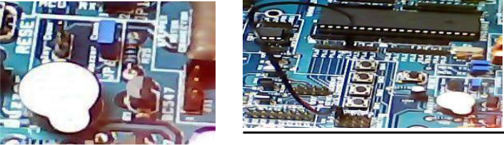

-28-

EXPERIMENT – 3

Aim:

Write a Embedded C Program to interface LCD data pins to port P1 and display a message on it using 89V51RD2

Equipment Requirements:

Hardware Requirements :

- 89V51RD2 Development board

- A serial 9 pin cable wired one to one from female connector to male connector

- PC with serial port

- 9V adaptor

- Connecting jumper and Connecting Wires.

Software Requirements :

- Keil evaluation software

- Flash Magic tool.

Interfacing 16*2 LCD with 8051:
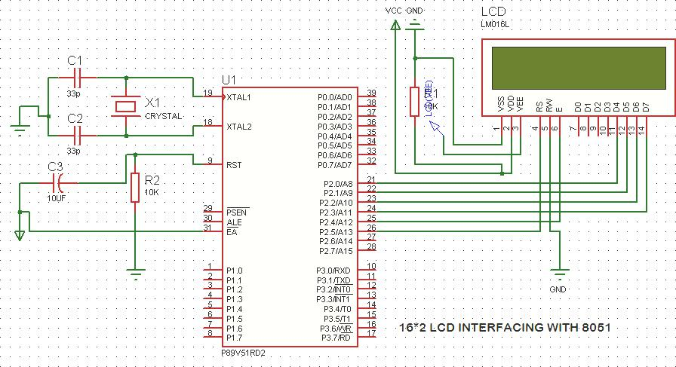

-29-

Source code:

/*Program to interface LCD data pins to port P1 and display a message on it.*/

#include <reg51.h>

#include "lcd.h" // refer LCD.H code for more to about LCD

void Delay_sec(unsigned char s);

main( )
{

LCD_init();

while(1)

{
LCD_clear();

Delay_sec(1);
LCD_row1();
LCD_puts(" welcome come to embedded lab ");

LCD_row2();

LCD_puts(" iare ");
Delay_sec(5);
LCD_clear();
Delay_sec(1);
LCD_clear();
LCD_row1();

LCD_puts("EMEBEDDED SYSTEMS ");
LCD_row2();

LCD_puts("AERONAUTICAL ENGG.");

Delay_sec(5);
}

}

void Delay_sec(unsigned char s)

{
unsigned char n;

for (n=0; n<s; n++)

{
LCD_delay(250);
LCD_delay(250);

}
}

-30-

Hardware configuration and Realization:

- Connect a 6 pin jumper or 6 pin bus from PORT 2 to LCD module available on board.

- Turn ON and OFF or reset the board, to view the output.

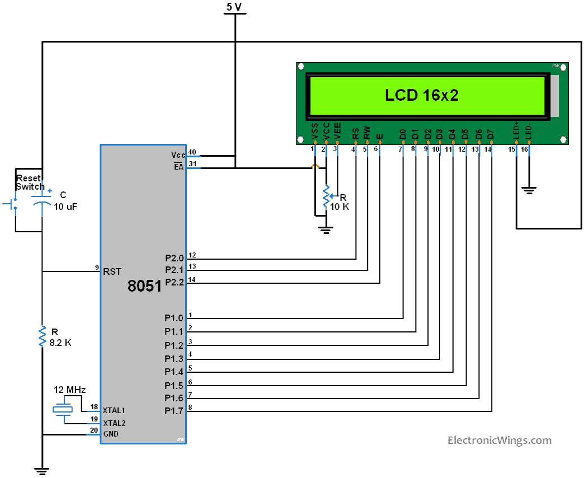

Results/Output verification:

After programming the code into the microcontroller just reset the microcontroller. You can see the text on the LCD.
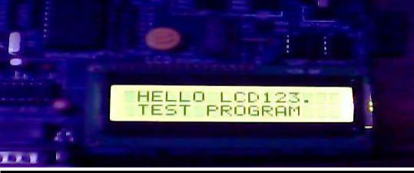

-31-

EXPERIMENT – 4

Aim:

Write a Embedded C Program to interface seven segment display using 89V51RD2

Equipment Requirements:

Hardware Requirements:

- 89V51RD2 Development board

- A serial 9 pin cable wired one to one from female connector to male connector

- PC with serial port

- 9V adaptor

- Connecting jumper and Connecting Wires.

Software Requirements :

- Keil evaluation software

- Flash Magic tool.

INTERFCAING SEVEN SEGMENT DISPLAY WITH 8051:
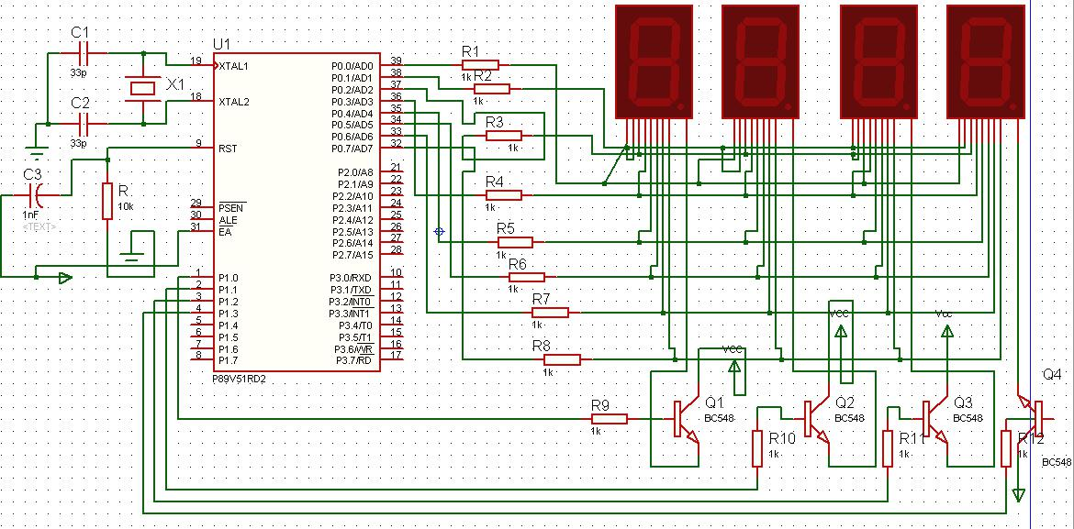

-32-

Source code:

/*Program to interface seven segment display unit.*/ #include <REG51.H>

#include <stdio.h>

#define LEDPORT P0

sbit CTRL0 = P1^0;

sbit CTRL1 = P1^1;
sbit CTRL2 = P1^2;
sbit CTRL3 = P1^3;

#define | ZERO |  | 0x02
#define | ONE | 0x9E
#define | TWO | 0x24
#define | THREE | 0x0C
#define | FOUR | 0x98
#define | FIVE | 0x48
#define | SIX | 0x40
#define | SEVEN | 0x1E
#define | EIGHT | 0x00
#define | NINE | 0x18
#define | TEN | 0x10
#define | ELEVEN | 0xC0
#define | TWELVE | 0x62
#define | THIRTEEN |  | 0x84
#define | FOURTEEN |  | 0x60
#define | FIFTEEN |  | 0x70

void Delay(void);

void main (void)
{

CTRL0 = 1;
CTRL1 = 1;

CTRL2 = 1;

CTRL3 = 1;

while(1)
{

LEDPORT = ZERO;
Delay();

LEDPORT = ONE;

Delay();
LEDPORT = TWO;
Delay();

-33-

LEDPORT = THREE;
Delay();

LEDPORT = FOUR;
Delay();
LEDPORT = FIVE;
Delay();

LEDPORT = SIX;

Delay();
LEDPORT = SEVEN;
Delay();

LEDPORT = EIGHT;
Delay();

LEDPORT = NINE;

Delay();

LEDPORT = TEN;
Delay();

LEDPORT = ELEVEN;
Delay();
LEDPORT = TWELVE;
Delay();

LEDPORT = THIRTEEN;

Delay();

LEDPORT = FOURTEEN;

Delay();
LEDPORT = FIFTEEN;

Delay();
}
}

void Delay(void)
{
int j;
int i;

for(i=0;i<30;i++)
{

for(j=0;j<10000;j++)
{

}
}
}

-34-

HARWARE CONFIGURATION:

To check the output connects the wires as shown and press any key from the keypad that value should be displayed on seven segments.
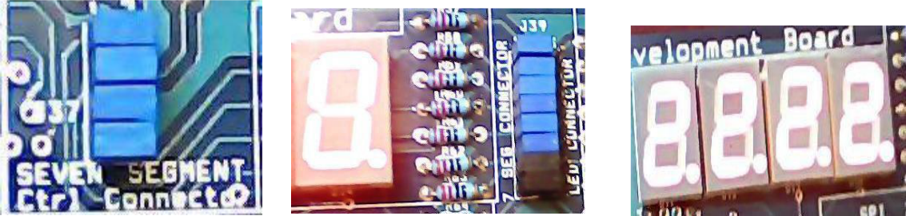

Result:

Output shown on the seven segment display

-35-

EXPERIMENT – 5

Aim:

Write a Embedded C Program to 4*4 interface keyboard. Whenever a key is pressed, it should be displayed on LCD using 89V51RD2

Equipment Requirements:

Hardware Requirements:

- 89V51RD2 Development board

- A serial 9 pin cable wired one to one from female connector to male connector

- PC with serial port

- 9V adaptor

- Connecting jumper and Connecting Wires.

Software Requirements:

- Keil evaluation software

- Flash Magic tool.

4*4 Matrix keyboard interfacing with 8051:
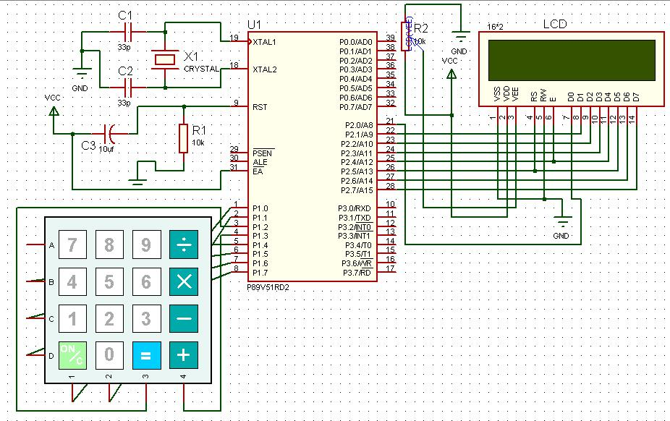

-36-

Source code:

/*Program to interface keypad. Whenever a key is pressed, it should be displayed on LCD.*/

#include <reg51.h>

#include"lcd.h"

sbit C1 = P1^0;
sbit C2 = P1^1;
sbit C3 = P1^2;
sbit C4 = P1^3;
sbit R1 = P1^4;
sbit R2 = P1^5;

sbit R3 = P1^6;
sbit R4 = P1^7;

unsigned char key;

void Delay(unsigned int);

void delay()

{

unsigned int i;

for (i=0; i<10; i++);

/* For 1 ms */

}

unsigned char READ_SWITCHES (void)

{

// initialize the port for inputs

  - P1.0 to p1.3 are outpot; and P1.4 to P1.7 are inputs
- the keybad is connected to port 1

- make all rows = 1

R4=1;

R3=1;
R2=1;
R1=0;

//test row 1
if (C1 == 0)

{ // key 1 is presed

delay(); //debounce

while (C1==0);
return 1;

//wait until release the key

}
if (C2 == 0)

{
delay();

while (C2==0);

//key 2 is pressed
//debounce

//wait until release the key

-37-

return 2;
}

if (C3 == 0)

{ //key 3 is pressed
delay(); //debounce
while (C3==0); //wait until release the key

return 3;
}
if (C4 == 0)
{ //key 4 is pressed

delay(); //debounce
while (C4==0); //wait until release the key

return 4;

}
//test row 2

R4=1;
R3=1;
R2=0;
R1=1;

if (C1 == 0)
{ //key 5 is pressed
delay(); //debounce
while (C1==0); //wait until release the key

return 5;

}
if (C2 == 0)

{ //key 6 is pressed
delay(); //debounce
while (C2==0); //wait until release the key

return 6;

}
if (C3 == 0)

{ //key 6 is pressed
delay(); //debounce
while (C3==0); //wait until release the key
return 7;

}

if (C4 == 0)
{ //key 7 is pressed

delay(); //debounce
while (C4==0); //wait until release the key

return 8;

}
//test row 3

-38-

R4=1;
R3=0;
R2=1;
R1=1;

if (C1 == 0)
{
delay();

while (C1==0);
return 9;

//key 8 is pressed
//debounce

//wait until release the key

}
if (C2 == 0)
{

delay();

while (C2==0);
return 10;

//key 9 is pressed

//debounce

//wait until release the key

}

if (C3 == 0)
{
delay();

//key A is pressed
//depounce

while (C3==0);

//wait until release the key

return 11;

}

if (C4 == 0)
{

delay();

while (C4==0);

return 12;

//key B is pressed

//depounce

//wait until release the key

}

//test row 4

R1=1;
R2=1;
R3=1;
R4=0;

if (C1 == 0)

{

delay();

while (C1==0);
return 13;

//key C is pressed

//depounce

//wait until release the key

}
if (C2 == 0)

{
delay();

while (C2==0);
return 14;

//key D is pressed
//depounce

//wait until release the key

-39-

}
if (C3 == 0)

{

delay();

while (C3==0);
return 15;

//key E is pressed

//depounce

//wait until release the key

}
if (C4 == 0)

{
delay();

while (C4==0);
return 16;

//key C is pressed
//depounce

//wait until release the key

}

return 0;

// Means no key has been pressed

}

void main (void)
{
P1 =0x0f;
P3=0x00;

LCD_init();
LCD_row1();

LCD_puts("< SERIAL KEYPAD >");
LCD_row2();
LCD_puts(" INTERFACING ");
Delay(3);

while(1)
{

key=READ_SWITCHES();
if(key)

{
P3 = key-1;
LCD_clear();
LCD_row1();

LCD_puts("< SERIAL KEYPAD >");
LCD_row2();

LCD_puts("KEY : ");

switch(key)
{

case 1:
{
LCD_putc('0');

break;

-38-

}

case 2:
{

LCD_putc('1');
break;

}

case 3:

{
LCD_putc('2');
break;

}

case 4:
{

LCD_putc('3');
break;

}

case 5:
{
LCD_putc('4');

break;

}

case 6:
{

LCD_putc('5');
break;

}

case 7:

{
LCD_putc('6');

break;
}

case 8:

{
LCD_putc('7');
break;
}

case 9:

{
LCD_putc('8');

break;

-39-

}

case 10:
{

LCD_putc('9');
break;

}

case 11:
{
LCD_putc('A');

break;
}

case 12:
{
LCD_putc('B');
break;

}

case 13:
{
LCD_putc('C');

break;

}

case 14:
{

LCD_putc('D');
break;
}

case 15:
{
LCD_putc('E');

break;
 | }
case 16: | }
 | {

-40-

LCD_putc('F');
break;

}// switch

}//if

}//while
}//main

void Delay(unsigned int duration)
{

unsigned int r2;
for (r2 = 0; r2<= duration;r2++)

{
LCD_delay(250);
LCD_delay(250);

}
}

Hardware configuration and realization:

- Connect a 6 pin jumper or 6 pin bus from PORT 2 to LCD module available on board.

- Connect 8 pin jumper to the hex keypad module on the board.

- Turn ON and OFF or reset the board, to view the output.

Results/Output verification:

After programming the code into the microcontroller just reset the microcontroller. You can listen to the buzzer buzzing.
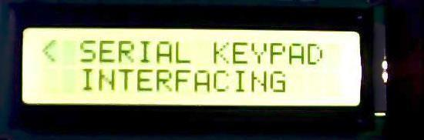

-41-

-42-

EXPERIMENT – 6(a)
Aim:

Write an Embedded C program for serial communication between Microcontroller to PC.
Program to transmit message from microcontroller to PC serially using RS232.

Equipment Requirements:

Hardware Requirements:

- 89V51RD2 Development board

- A serial 9 pin cable wired one to one from female connector to male connector

- PC with serial port

- 9V adaptor

- Connecting jumper and Connecting Wires.

Software Requirements:

- Keil evaluation software

- Flash Magic tool.

- Terminal

Interfacing Serial communication between MCU to PC:
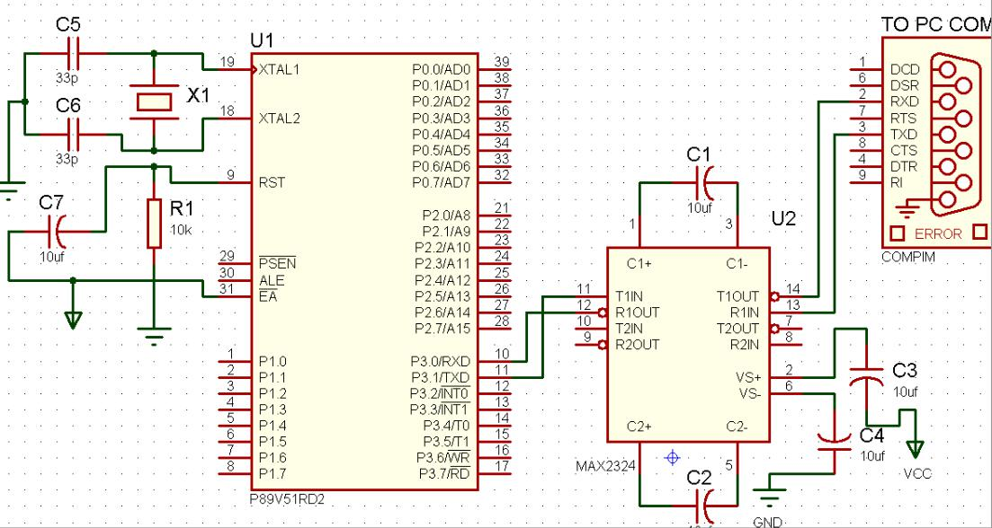

-43-

Basic Theory of 8051 Serial commutations:

UART (Universal Asynchronous Receiver and Transmitter)

One of the microcontroller features making it so powerful is an integrated UART, better known as a serial port. It is a full-duplex port, thus being able to transmit and receive data simultaneously and at different baud rates. Without it, serial data send and receive would be an enormously complicated part of the program in which the pin state is constantly changed and checked at regular intervals. When using UART, all the programmer has to do is to simply select serial port mode and baud rate. When it's done, serial data transmit is nothing but writing to the SBUF register, while data receive represents reading the same register. The microcontroller takes care of not making any error during data transmission.
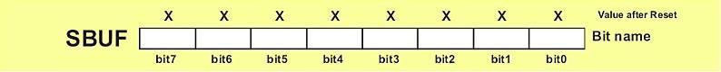

Serial port must be configured prior to being used. In other words, it is necessary to

determine how many bits is contained in one serial ―word‖, baud rate and synchronization clock source.

The whole process is in control of the bits of the SCON register (Serial Control).
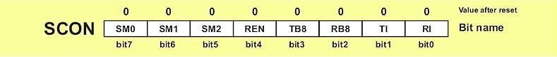

SM0 - Serial port mode bit 0 is used for serial port mode selection.

SM1 - Serial port mode bit 1.

SM2 - Serial port mode 2 bit, also known as multiprocessor communication enable bit. TI - Transmit Interrupt flag is automatically set at the moment the last bit of one byte is sent. It's a signal to the processor that the line is available for a new byte transmit. It must be cleared from within the software.

RI - Receive Interrupt flag is automatically set upon one byte receive. It signals that byte is received and should be read quickly prior to being replaced by a new data. This bit is also cleared from within the software.

-44-

SM0 | SM1 |  | Mode Description | Baud Rate
0 | 0 | 0 | 8-bit Shift Register | 1/12 the quartz frequency
0 | 1 | 1 | 8-bit UART | Determined by the timer 1
1 | 0 | 2 | 9-bit UART | 1/32 the quartz frequency (1/64
 | the quartz frequency)
1 | 1 | 3 | 9-bit UART | Determined by the timer 1
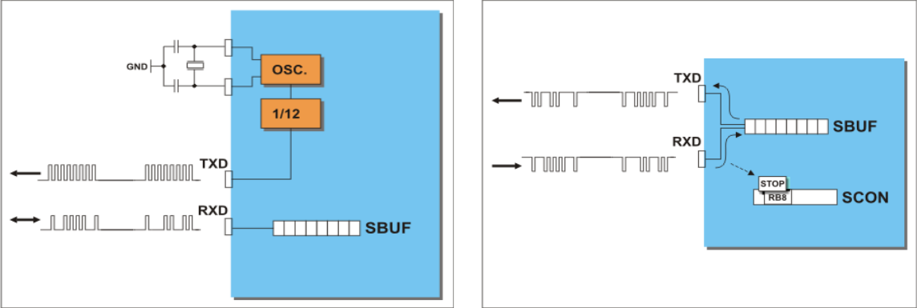

Source code:

/*Program to transmit a message from Microcontroller to PC serially using RS232.*/

#include <REG51.h> /* define 8051 registers */

void SendChar(unsigned char x);

void DisplayMesPC(unsigned char *);

void serial_init(void);

unsigned char *mes;

void main (void)

{

/* main program start */

serial_init();

mes = "\r\nInstitute of Aeronautical engg\r\n\r\nWelcome to Serial communication Demo \r\n";

DisplayMesPC(mes);

mes = "\r\nif above txt visible, then transmission sucess\r\n";

-45-

DisplayMesPC(mes);

while(1);

}

void SendChar(unsigned char x) // transmit function to send character to PC

{

SBUF =x; // wrting the character into the serial buffer

TI = 0; // Clearing the Transmit empty flag

while(!TI); // wating for end of trasmission. after transmission

the TI flag will set.

}

void DisplayMesPC(unsigned char *mes)

{

int counter;

for (counter=0;mes[counter]!='\0';counter++)

{

SendChar(mes[counter]);

}

}

void serial_init()

{

TMOD = 0x20; /* GATE OFF,C/#T = 0, M1 M0 = 10(8 BIT AUTO

RELOAD) TIMER 0 ,TIMER 1 IN MODE 2(AUTO RELOAD MODE)*/

SCON = 0x50; /* SERIAL PORT IN MODE2 8-BIT UART VARIABLE

BAUDRATE */

TH1 = 0xfd; /* TIMER 1 FOR BAUD RATE GEN(9.6K)*/

TR1 = 1; /* baud rate timer start*/

}

-46-

Flow chart:
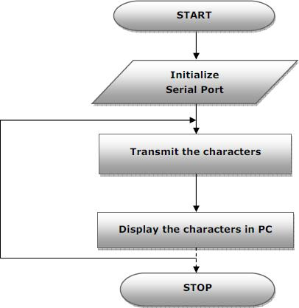

Results/Output verification:

Now the program is running on Microcontroller. And the output can be seen in the board. You can see terminal device .

-47-

EXPERIMENT – 6(b)

Aim:

Write an Embedded C program for serial communication between Microcontroller to PC.
Program to receive a message from PC to microcontroller serially using RS232.

Equipment Requirements:

Hardware Requirements:

- 89V51RD2 Development board

- A serial 9 pin cable wired one to one from female connector to male connector

- PC with serial port

- 9V adaptor

- Connecting jumper and Connecting Wires.

Software Requirements:

- Keil evaluation software

- Flash Magic tool.

- Terminal

Interfacing Serial communication between MCU to PC:

-48-

Basic Theory of 8051 Serial commutations:

UART (Universal Asynchronous Receiver and Transmitter)

One of the microcontroller features making it so powerful is an integrated UART, better known as a serial port.

It is a full-duplex port, thus being able to transmit and receive data simultaneously and at different baud rates. Without it, serial data send and receive would be an enormously complicated part of the program in which the pin state is constantly changed and checked at regular intervals. When using UART, all the programmer has to do is to simply select serial port mode and baud rate. When it's done, serial data transmit is nothing but writing to the SBUF register, while data receive represents reading the same register. The microcontroller takes care

of not making any error during data transmission.

Serial port must be configured prior to being used. In other words, it is necessary to

determine how many bits is contained in one serial ―word‖, baud rate and synchronization clock source.

The whole process is in control of the bits of the SCON register (Serial Control).

SM0 - Serial port mode bit 0 is used for serial port mode selection.

SM1 - Serial port mode bit 1.

SM2 - Serial port mode 2 bit, also known as multiprocessor communication enable bit. TI - Transmit Interrupt flag is automatically set at the moment the last bit of one byte is sent. It's a signal

to the processor that the line is available for a new byte transmit. It must be cleared from within the software.

RI - Receive Interrupt flag is automatically set upon one byte receive. It signals that byte is received and

should be read quickly prior to being replaced by a new data. This bit is also cleared from within the software.

SM0

SM1

Mode Description

Baud Rate

0

0

0 8-bit Shift Register

1/12 the quartz frequency

-49-

0 | 1 | 1 | 8-bit UART | Determined by the timer 1
0 | 1 |  | 2 9-bit UART | 1/32 the quartz frequency
1 | 1 | 3 | 9-bit UART | Determined by the timer 1

Source code:

/*Program to receive a message from PC to microcontroller serially using RS232.*/

#include <reg51.h>

unsigned char ReceiveSerial() {

unsigned char c;

TMOD = 0x20; /* configure timer for the correct baud rate*/ TH1 = 0xe6;
1200 bps for 12 MHz clock */

TCON = 0x00; /* Set timer to not running */

/*

SCON = 0x50; /* Set Serial IO to receive and normal mode */ TR1 = 1;
start timer to Receive */

while( (SCON & 0x01) == 0 ) /* wait for receive data */;
c = SBUF;
return c;

/*

}

void main(void) {

unsigned char c;

while( 1 )
{

char ReceivSerial()

}
}

-50-

Flow chart:

Results/Output verification:

Now the program is running on Microcontroller. And the output can be seen in the board.

-51-

EXPERIMENT – 7

Program to interface Stepper Motor to rotate the motor in clockwise and anticlockwise directions

Aim:

Write a Embedded C Program to interface Stepper Motor to rotate the motor in clockwise and anticlockwise directions

Equipment Requirements:

Hardware Requirements:

- 89V51RD2 Development board

- A serial 9 pin cable wired one to one from female connector to male connector

- PC with serial port

- 9V adaptor

- Connecting jumper and Connecting Wires.

6.Stepper motor

Software Requirements:

- Keil evaluation software

- Flash Magic tool.

Stepper Motor Interfacing with 8051:
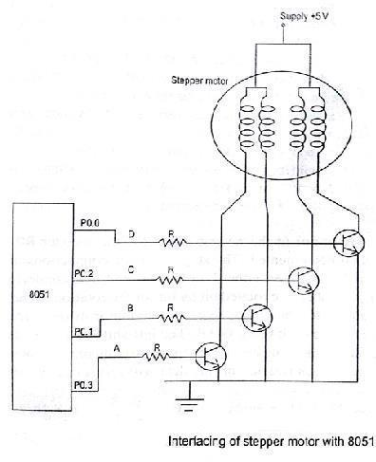

-52-

Switching sequence : One Phase excitation (Wave drive)
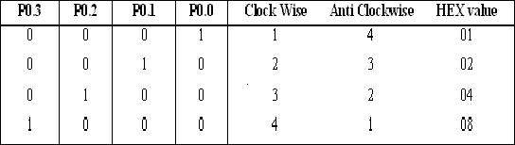

Switching sequence: Two phase excitation (High torque excitation)
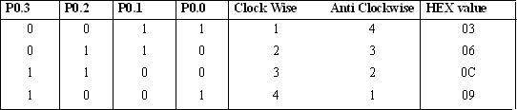

Source code:

/*Program to interface Stepper Motor to rotate the motor in clockwise and anticlockwise directions*/

#include <reg51.h>

sbit SW1 = P1^0;

sbit SW2 = P1^1;

void motor_delay(int sec) ;

void main(void)

{

P3=0x00;

SW1 = 0;

SW2 = 0;

while(1)

{

-53-

if(SW1 == 0)

{

P3 = 0x50;

motor_delay(2);

P3 = 0x90;

motor_delay(2);

P3 = 0xA0;

motor_delay(2);

P3 = 0x60;

motor_delay(2);

}

else if(SW2 == 0)

{

P3 = 0x60;

motor_delay(2);

P3 = 0xA0;

motor_delay(2);

P3 = 0x90;

motor_delay(2);

P3 = 0x50;

motor_delay(2);

}

}

}

void motor_delay(int sec)

{

int i,j,secd;

for (secd=0;secd<=sec;secd++)

for(i=0;i<=4;i++)

for (j= 0;j<=800;j++)

-54-

{
}

}

Result:

- Connector the jumpers at the stepper motor driver IC.

- Connect the switch pins to the port pins selected.

- Connect the Stepper motor to the available pins beside the serial port.
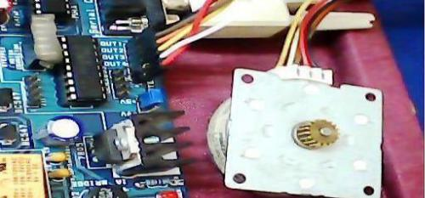
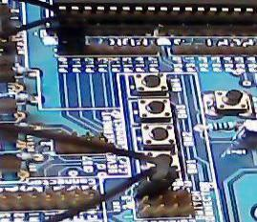

-55-

EXPERIMENT – 8

Develop necessary interfacing circuit to read data from i) temperature sensor and process using 89c51 sdk, the data has to display terminal window

Aim:

Write a program to read data from temperature sensor and display the temperature value.

Equipment Requirements:

Hardware Requirements:

- 89V51RD2 Development board

- A serial 9 pin cable wired one to one from female connector to male connector

- PC with serial port

- 9V adaptor

- Connecting jumper and Connecting Wires.

Software Requirements:

- Keil evaluation software

- Flash Magic tool.

- Terminal device

Temperature Sensor Interfacing with 8051:

-56-

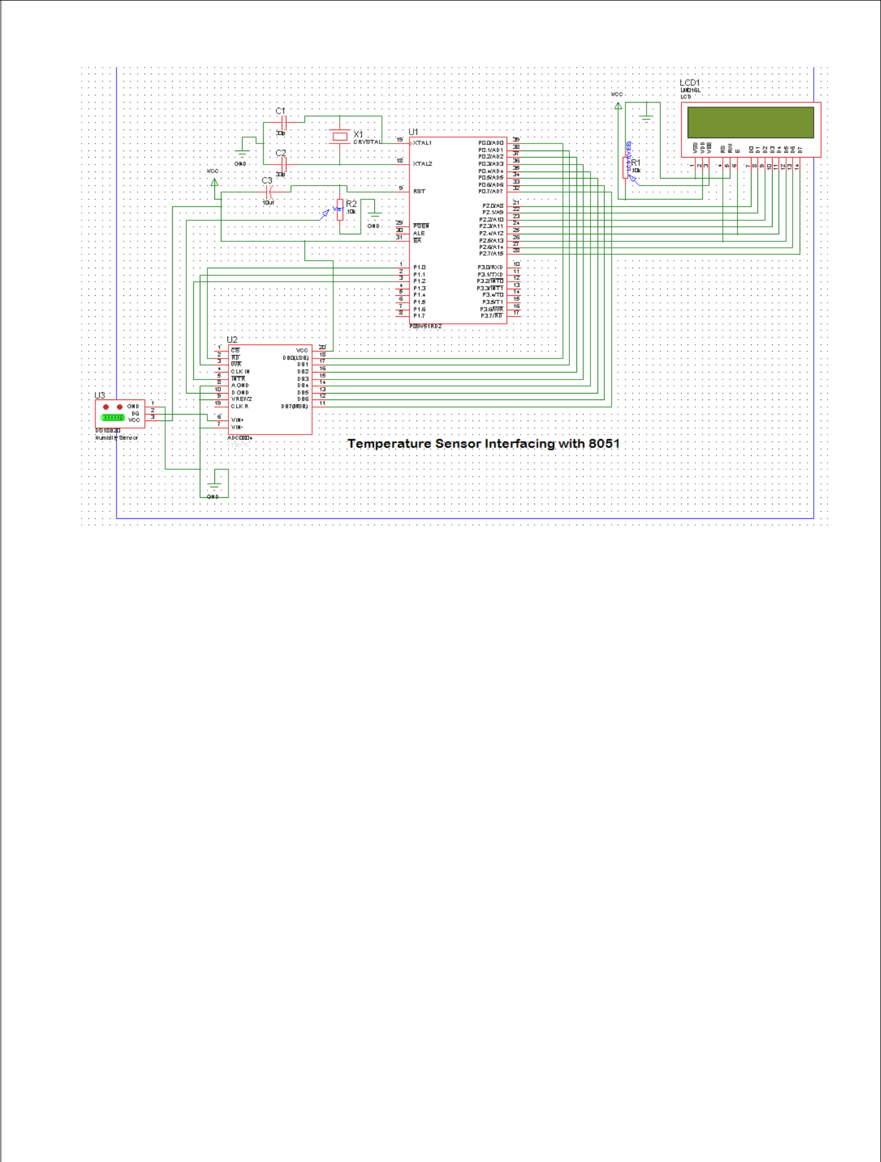

Source code:

/*Program to get analog input from Temperature sensor and display the temperature value on PC Monitor.*/

#include <reg51.h> #include "lcd.h"

/* define 8051 registers */

sbit rd=P1^0;

sbit wr=P1^1;

sbit intr=P1^2;

//Read signal P1.0

//Write signal P1.1

//INTR signal P1.3

void conv();

void read();
void display();

//Start of conversion function

//Read ADC function

void Delay(int a);
void SendChar(unsigned char x);

void DisplayMesPC(unsigned char *);

unsigned char *mes;
unsigned char adc_val;

unsigned int value,temp,temp1,temp2,temp3;

void Delay(int a)

-57-

{
char i;

for(i=0;i<a;i++)

{
LCD_delay(250);
LCD_delay(250);

}
}

void serial_init()
{

= 0x20; /* GATE OFF,C/#T = 0, M1 M0 = 10(8 BIT AUTO RELOAD) TIMER 0 ,TIMER 1 IN 2(AUTO RELOAD MODE)*/

SCON = 0x50; /* SERIAL PORT IN MODE2 8-BIT UART VARIABLE BAUDRATE*/

TH1 = 0xfd;

/* TIMER 1 FOR BAUD RATE GEN(9.6K)*/

TR1 = 1;

/* baud rate timer start*/

}

void PowerOn( )
{

unsigned char inner, outer;

for (outer = 0x00; outer < 0x10; outer++)

{

for (inner = 0x00; inner < 0xFF; inner++);
}

LCD_init();

for (inner = 0; inner < 10; inner++)
LCD_delay(2);

serial_init();
}

void main()
{
P0=0xFF;
P1=0x04;

PowerOn();

while(1)
{

-58-

LCD_clear();
LCD_row1();

LCD_puts("Temperature sensor ");
DisplayMesPC("\r\nTemparature Value : ");

conv();
read();

display();
Delay(4);

//Start conversion
//Read ADC

//Send the read value PC and LCD

}
}

void conv()
{

wr = 0;
wr = 1;
while(intr);

//Make WR low
//Make WR high

//Wait for INTR to go low

}

void read()
{

rd = 0;

adc_val = P0;
rd = 1;

//Make RD low

//Read ADC port
//Make RD high

}

void display()
{

// display the adc vvalue in the form of milli volts

LCD_row2();

LCD_puts(" Temp :");

value=adc_val;

value=value*196;

value=value/100;

//since resolution is 5V/255=19.6mv

// 10 division by 196 instead 19.6 another 10 is 1*

corresponds 10mv

if(value>=1000)
{
temp=value/1000;
adc_val=temp+48;

LCD_putc(adc_val);
SendChar(adc_val);
}

temp1=value%1000;

if(temp1>=100&&temp1<=999){
temp=temp1;

-59-

temp=temp/100;
adc_val=temp+48;
LCD_putc(adc_val);
SendChar(adc_val);

}
Else

{
LCD_putc('0');
SendChar('0');

}

temp2=temp1%100;
if(temp2>=10&&temp2<=99)

{
temp=temp2;
temp=temp/10;

adc_val=temp+48;
LCD_putc(adc_val);
SendChar(adc_val);

}
else

{
LCD_putc('0');
SendChar('0');

}

temp3=temp2%10;
if(temp3>0&&temp3<10){
temp=temp3;
adc_val=temp+48;
LCD_putc(adc_val);
SendChar(adc_val);
}

else {
LCD_putc('0');

SendChar('0');
}

LCD_putc(0XDF);
SendChar('*');

SendChar(' ');
SendChar('C');
LCD_putc('*');
LCD_putc('C');
}

void SendChar(unsigned char x) // transmit function to send character to PC

-60-

{
SBUF =x; // wrting the character into the serial buffer

TI = 0; // Clearing the Transmit empty flag

while(!TI); // wating for end of trasmission. after transmission the TI flag will set.
}

void DisplayMesPC(unsigned char *mes)
{

int counter;
for(counter=0;mes[counter]!='\0';counter++)

{

SendChar(mes[counter]);
}

}

Hardware configuration:

To test the board Power supply cable should be connected to the Board and serial cable must be connected to

the computer. The Data line of the ADC is connected to the P0 of microcontroller. The RD, WR, INTR (J32)

signals are connected to the P1.0, P1.1, P1.2 respectively. The Jumper should be connected at J22. To Connect

Temperature sensor to ADC input Connect J22 1&2 (Temp sensor) with jumper The temperature is displayed in LCD and same thing displayed on the PC.
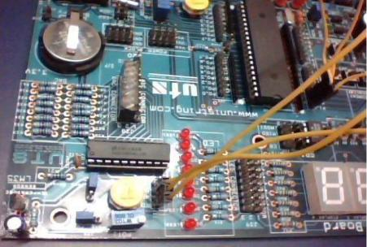

RESULTS:

To check the output connect the hardware as shown above diagram, increase the temperature on the sensor side then we will see the variation on sensor data on both HyperTerminal and lcd.
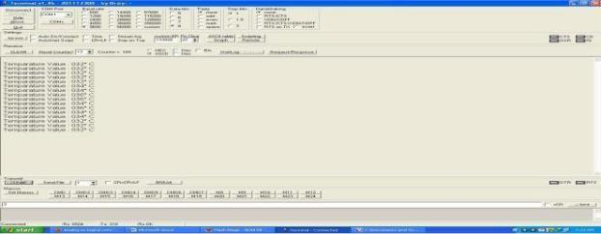

-61-

EXPERIMENT –9

Write a Program to

Port RTOS on to 89V51 Microcontroller and verify. Run 2 to 3 tasks simultaneously on 89V51 SDK. Use LCD interface, LED interface, Serial communication.

Aim:

Write an Embedded C program to sort RTOS on to 89V51 Microcontroller and verify. Run 2 to 3 tasks simultaneously on P89V51RD2.Use LCD interface, LED interface, Serial communication.

Equipment Requirements:

Hardware Requirements:

- 89V51RD2 Development board

- A serial 9 pin cable wired one to one from female connector to male connector

- PC with serial port

- 9V adaptor

- Connecting jumper and Connecting Wires.

Software Requirements:

- Keil evaluation software

- Flash Magic tool.

RTOS Introduction:
What is a real-time System?

Timeliness is the single most important aspect of a real -time system. These systems respond to a series of external inputs, which arrive in an unpredictable fashion. The real-time systems process these inputs, take appropriate decisions and also generate output necessary to control the peripherals connected to them. As defined by Donald Gillies "A real-time system is one in which the correctness of the computations not only depends upon the logical correctness of the computation but also upon the time in which the result is produced. If the timing constraints are not met, system failure is said to have occurred."

It is essential that the timing constraints of the system are guaranteed to be met. Guaranteeing timing behavior requires that the system be predictable. The design of a real -time system must specify the timing requirements of the system and ensure that the system performance is both correct and timely. There are three types of time constraints:

Hard: A late response is incorrect and implies a system failure. An example of such a system is of medical equipment monitoring vital functions of a human body, where a late response would be considered as a failure.

Soft: Timeliness requirements are defined by using an average response e time. If a single computation is late, it is not usually significant, although repeated late computation can result in system failures. An example of such a system includes airlines reservation systems.

-62-

Firm: This is a combination of both hard and soft timeliness requirements. The computation has a shorter soft requirement and a longer hard requirement. For example, a patient ventilator must mechanically ventilate the patient a certain amount in a given time period. A few seconds' delay in the initiation of breath is allowed, but not more than that.

Experimental procedure:

Open the keil IDE and do the same procedure like create new project and build the application. Then open Flash magic and download the hex file. Please refer the above experimental procedure for keil4 IDE. In this RTOS experiment we have to do few more settings for creating new project (if you want to create new project then only do these settings),just follow the settings as below mentioned.

After creating new project file go to target and do these settings: SELECT TARGET and right click on target settings and select RAM size is 0X0000 to 0X1000.Again go to settings and select C51 and select LEVEL 9. And do the below

Source code:

/*Port RTOS on to 89V51 Microcontroller and verify.

- Run 2 to 3 tasks simultaneously on 89V51 SDK.
- Use LCD interface, LED interface, Serial communication. */

#include "rtos.h"
#include"uart.h"
#include"lcd.h"

unsigned char task_time_counter1=0,task_time_counter2,task_time_counter3=0; struct generic_sync xdata mut;
sbit | LED1 = | P0^0;
sbit | LED2 = | P0^1;
sbit | LED3 = | P0^2;

void PowerOn()
{

unsigned char inner, outer;

for (outer = 0x00; outer < 0x10; outer++)

{

for (inner = 0x00; inner < 0xFF; inner++);
}

LCD_init();
for (inner = 0; inner < 10; inner++)
LCD_delay(2);

serial_init();

}

-63-

void LED_TASK()
{

while(1) {
k_acquire(&mut);
k_yield();

if(task_time_counter1==20){
task_time_counter1=0;
LED1=LED1 ^ 1;

DisplayMesPC("\r\nLED Task Running");
}

task_time_counter1++;

k_release(&mut);
k_yield();

}

}

void LCD_TASK() {
unsigned char counter=0;

LCD_clear();

LCD_row1(); LCD_puts("LCD Task Running"); LCD_row2();

while(1) {
k_acquire(&mut);
k_yield();

if(task_time_counter2==5){
LCD_putc(counter+48);
counter++;

LED3=LED3 ^ 1;
task_time_counter2=0;
DisplayMesPC("\r\nLCD Task Running");
if(counter>15){
counter=0;
LCD_row2();

LCD_puts(" ");
LCD_row2();

}
}

task_time_counter2++;
k_release(&mut);

k_yield();

}

-64-

}

void UART_TASK() {
while(1) {

k_acquire(&mut);
k_yield();

if(task_time_counter3==10){
task_time_counter3=0;

LED2=LED2 ^ 1;

DisplayMesPC("\r\nUART Task Running");
}

task_time_counter3++;

k_release(&mut);
k_yield();

}

}

void main()
{
P0=0x00;

PowerOn();
DisplayMesPC("\r\nRTOS For 8051 Microcontroller");

k_create_mutex(&mut);

k_task_create(LED_TASK, "a", 1);
k_task_create(LCD_TASK, "b", 1);
k_task_create(UART_TASK, "c", 1);

k_start();

}

Hardware configuration:
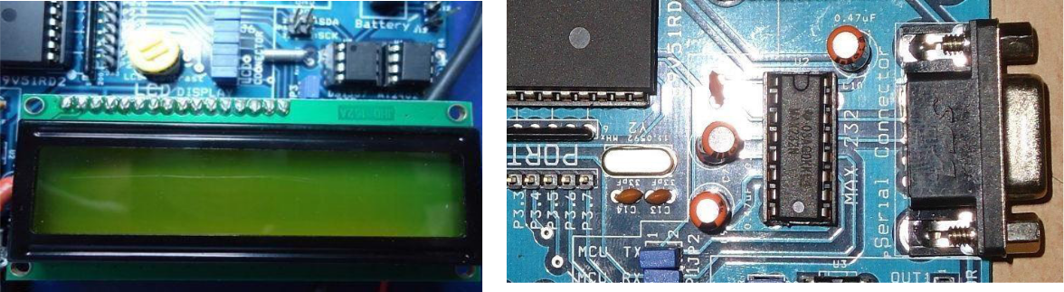

-65-

To test the board

Power supply cable should be connected to the M7 Board and serial cable must be connected to the computer.

Jumpers should be connected to J39[LED‘s],JP3 and J6[LCD]. To check the output just reset the board and give proper connections and check the output on LCD , LED and on hyperterminal. H ere we are assigned three leds for 3 tasks one led for led,second one for lcd and third one for UART. There you can observe the the task time on each and every led.
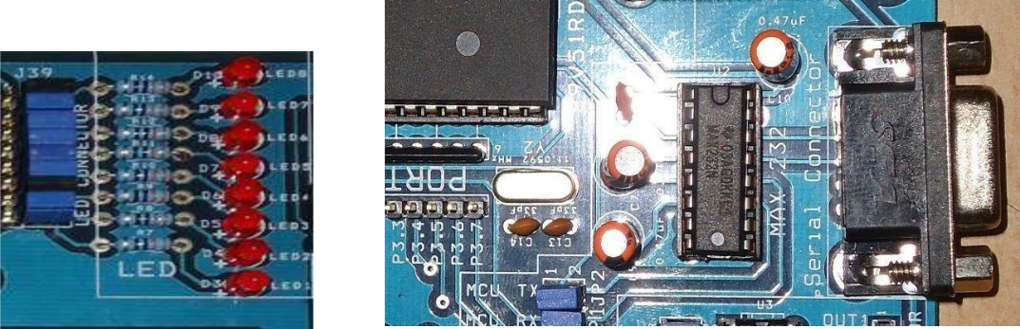

-66-

Result

You can find on LCD display data and led blinks and UART data displayed this terminal like this.
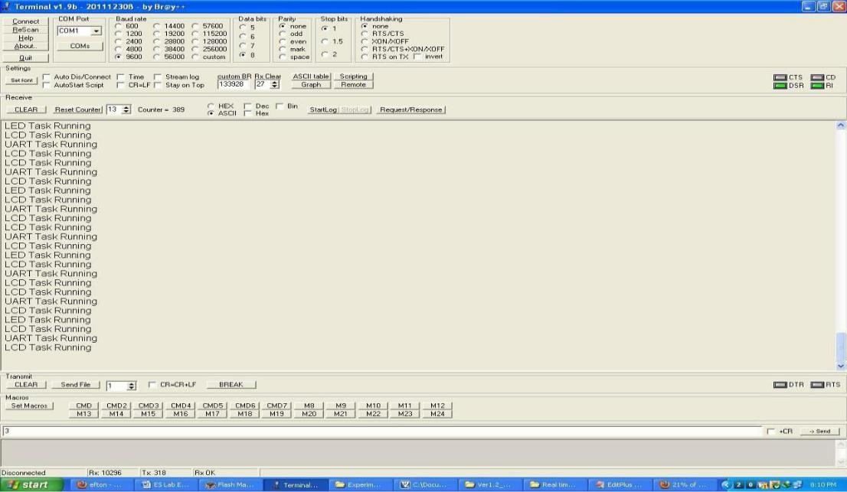

-67-

EXPERIMENT-10

Analog to Digital Converter unit (ADC 0809)

AIM: Write a program to develop analog to digital converter using 89C51 board.

Program Code : Digital to analog (DAC)
#include<8051.h>

#define HIGH 01;

#define LOW 00;
xdata at 0xffc5 unsigned char swt;

idata unsigned char dat;

idata unsigned char i;

bit at(0x94) SCLK;

bit at(0x95) SDA;

bit ACK;

void I2C_Start(void);
void I2C_Stop(void);

void I2C_Write(unsigned char j);
unsigned char I2C_Read(void);
void Delay_Time();

void I2C_Start(void) //Start I2C by creating clock by setting and clearing the port pins
{

SCLK=LOW;

SDA=LOW;
Delay_Time();
SCLK = HIGH;
Delay_Time();

SDA=HIGH;

Delay_Time();

SDA = LOW;

Delay_Time();

SCLK = LOW;

}
void I2C_Stop(void) //Stop I2C operation by clearing the SCLK Pin
{

SCLK = LOW;
Delay_Time();

SDA = HIGH;

}
void I2C_Write(unsigned char j) // shifting data bit by bit to MSB and moving through i2c
{
dat=j;
for(i=0;i<8;i++)

{

-71-

SDA = dat & 0x80;

dat=dat<<1;
SCLK = HIGH;
Delay_Time();

SCLK = LOW;

}
SDA=HIGH;
Delay_Time();

SCLK = HIGH;

Delay_Time();

ACK = SDA;

Delay_Time();

SCLK = LOW;

}

unsigned char I2C_Read(void) //reading from i2c device bit by bit
{

unsigned char i,j;
j = 0;

i = SDA;
for(i=0;i<8;i++)
{

j<<=1;
SCLK = HIGH;

j |= SDA;

Delay_Time();

SCLK = LOW;

}
Delay_Time();
SDA = LOW;

Delay_Time();
SCLK = HIGH;

Delay_Time();
SCLK = LOW;

Delay_Time();
SDA = HIGH;

return j;
}

void main()

{

unsigned int i=0x00;
I2C_Start();

I2C_Write(0x9E); I2C_Write(0x40);

//send device address

//send device's control register address

I2C_Start();

I2C_Write(0x9E);

// send command for read

while(1)

{

-72-

if((swt & 0x1f)== 0x1E)

{
i=i+0x0a;

if(i>0xff)
i=0x00;

I2C_Write(i);
Delay_Time();

}

}
}

void Delay_Time()
{
unsigned int i;
for(i=0;i<=5000;i++);

}

ADC 0809 is an 8-channel 10

Digital form. In ADC section a jumper is provided to select either external analog input from signal conditioning as input source or can select internal 5V generator, which is variable from 0-5V. Th

the any of the port by using the Bus/connector. Reference voltage of 2.5V is given at the reference input so that the analog input span is 5V. In a sample program provided with the module the digital ou

Microcontroller, can be view on the hyper terminal of the PC Features of ADC0809:

Resolution: 8 Bits.
Operates ratio metrically or with 5VDC, 2.5VDC, or analog span adjusted

voltage reference.
Differential analog voltage inputs
Works with 2.5V voltage reference.
On-chip clock generator.
0V to 5V analog input voltage range with single 5V supply.
No zero adjusts required.

-73-

EXPERIMENT-11

Aim:
Program to interface DAC device with P89V51RD2 and observer the analog output in CRO.

Hardware and Software Requirement:

- Set port 1 as output port.

- Initialize port 1 as 00

- Go on incrementing value till max value is reached at port1, for the upward going part of the triangular wave.

- For 1kHz triangular wave, increase the value by 5 each time.

- Once max value is reached, decrease the value in same steps till min value is reached.

- Repeat in infinite loop.
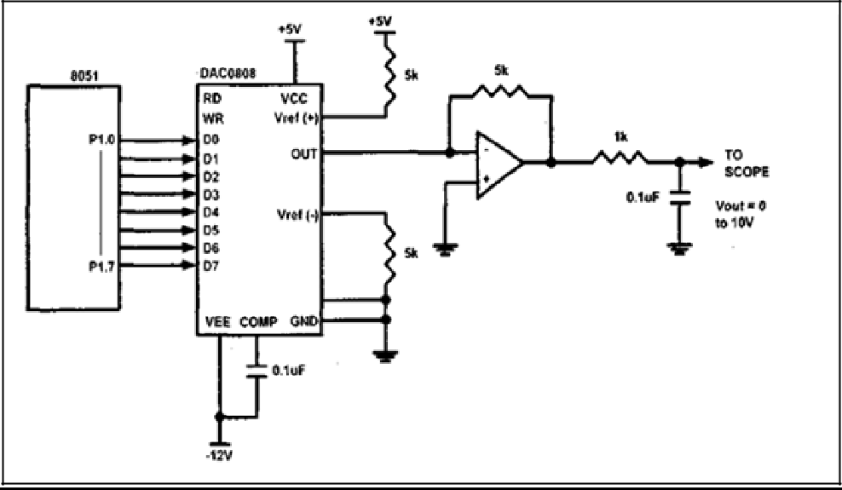

-74-

Hardware Connection
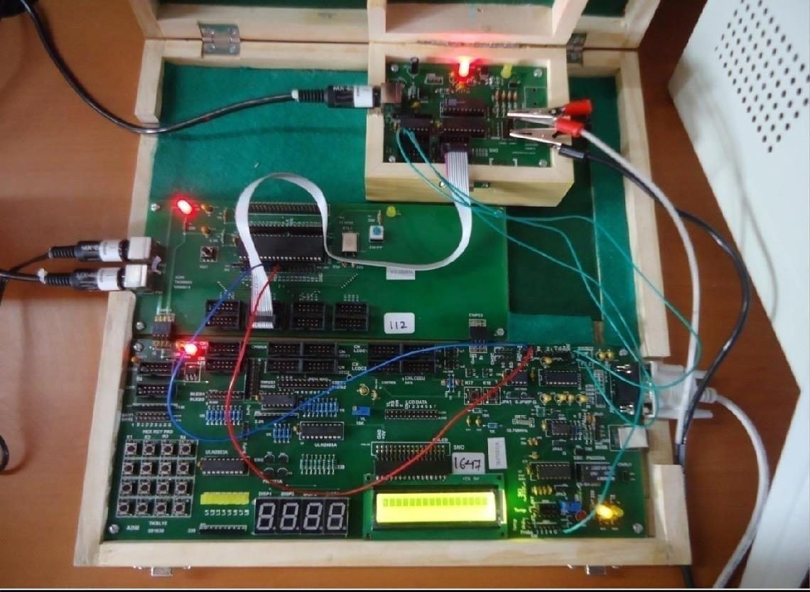

-75-

Actual Connection
Code
#include<reg51.h> |  | //Header file for 8051 void main() | // Start of main() function
{
P1 = 0x00; |  | // Initialize Port 1 as Output
while(1) |  | // Infinite Loop
{
do | // 1st do-while for upward portion of //triangular wave
{
P1 += 0x05; |  | // Increment P1 to get upward portion
}
while(P1<0xFF); |  | // stop loop after reaching max value do |  | // 2nd do-while for
downward portion of //triangular wave
{
P1 -= 0x05; |  | // Decrement P1to get downward portion
}
while(P1>0x00); |  | // stop loop after reaching lowest value
}
}

Expected Output
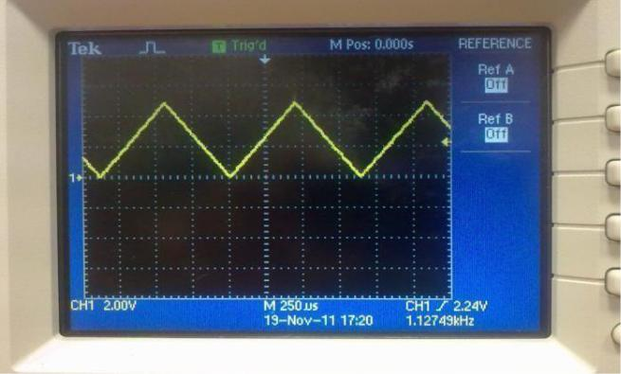

-76-

EXPERIMENT- 12

Program to interface Elevator.

Aim: Write a Program to interface a Elevator

Program :

#include<reg51.h>

void main(void)

{

unsigned char F[10]={0,1,2,3,4,5,6,7,8,9};

unsigned char req,cur,i,j;

P0=0x09;

cur=P0;

while(1)

{ P1=0x02; req=P1; if(cur==req)

{

P0=F[req];

}

else if(req>cur)

{

for(i=cur;i<=req;i++)

{ P0=F[i]; for(j=0;j<250;j++);

}

-76-

}

else

{

for(i=cur;i>=req;i--)

{ P0=F[i];

for(j=0;j<250;j++);

}

} cur=req; P0=F[cur];

}

}

Interfacing Model:

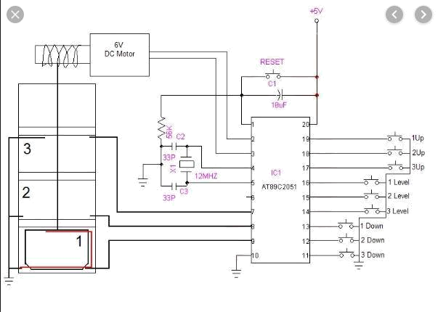

-78-

Result: Elevator is interfaced with 8051 microcontroller.

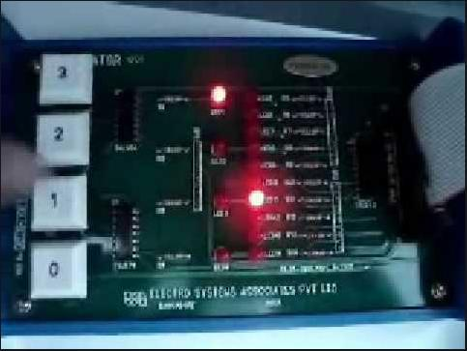

-79-

TEXT BOOKS:

- Computers and Components, Wayne Wolf, Elseveir.

- The 8051 Microcontroller, Third Edition, Kenneth J. Ayala, Thomson .

- Real time programmings , lyla B das

REFERENCES:

- Embedding system building blocks, Labrosse, via CMP publishers.

- Real time programmings, Raj Kamal, TMH.

- Micro Controllers, Ajay V Deshmukhi, TMH.

- Real time programming Design, Frank Vahid, Tony Givargis, John Wiley.

- Microcontrollers, Raj Kamal, Pearson Edition.

- An Embedded Software Primer, David E. Simon, Pearson Edition.

- ‗Embedded/Real-Time Systems‘, KVKKF Prasad, Dreamtech, Press

Web References:

- https://www.cadsoftusa.com/download-eagle/freeware/
- http://www.dauniv.ac.in/downloads/EmbsysRevEd_PPTs/Chap01Lesson_1Emsys.pdf
- http://en.wikipedia.org/wiki/Embedded_system
- http://www.atmel.in/Images/MCU_vs_MPU_Article.pdf

- http://maxembedded.com/2011/06/05/mcu-vs-mpu/
- http://www.cadsoft.de/wp-content/uploads/2011/05/V6_tutorial_en.pdf 6.

- http://www.mikrocontroller.net/attachment/17909/Protel_99_SE_Traning_Manual_P CB_ Desi gn.pdf

-80-

